**DAILY ONLINE ACTIVITIES SUMMARY**

|  |  |  |  |  |  |  |  |
| --- | --- | --- | --- | --- | --- | --- | --- |
| **Date:** | **10/06/2020** | | | | **Name:** | **Tushit Shukla** | |
| **Sem & Sec** | **4 sem & B sec** | | | | **USN:** | **4AL18CS093** | |
| **Online Test Summary** | | | | | | | |
| **Subject** | | OOC | | | | | |
| **Max. Marks** | | 30 | | **Score** | | 06 | |
| **Certification Course Summary** | | | | | | | |
| **Course** | 1. Java programing | | | | | | |
| **Certificate Provider** | | | **Great Learning** | **Duration** | | | **1s hr(spent by me on that day to learn)** |
| **Coding Challenges** | | | | | | | |
| **Problem Statement:**   1. Java Program to find the longest repeating sequence in a string string:acbdfghybdf 2. Given a matrix, the task is to print the boundary elements of the matrix and display their sum. Sample Output 1: Enter M (Rows) and N (Columns): 3, 3 Enter the Elements: 1 2 3 4 5 6 7 8 9 OUTPUT: The Input Matrix is: 1 2 3 4 5 6 7 8 9 The Boundary Elements are: 1 2 3 4 6 7 8 9 The Sum of Boundary elements of the Matrix is: 40   Sample Output 2: Enter M (Rows) and N (Columns): 4, 5 Enter the Elements: 1 2 3 4 5 6 7 8 9 10 11 12 13 14 15 16 17 18 19 20 OUTPUT: The Input Matrix is: 1 2 3 4 5 6 7 8 9 10 11 12 13 14 15 16 17 18 19 20 The Boundary Elements are: 1 2 3 4 5 8 9 12 13 16 17 18 19 20 The Sum of Boundary elements of the Matrix is: 147 | | | | | | | |
| **Status: Completed** | | | | | | | |
| **Uploaded the report in Github** | | | | **Yes** | | | |
| **If yes Repository name** | | | | <https://github.com/tushitshukla29/lockdown-program> | | | |
| **Uploaded the report in slack** | | | | **Yes** | | | |

**Internal Assessment:**

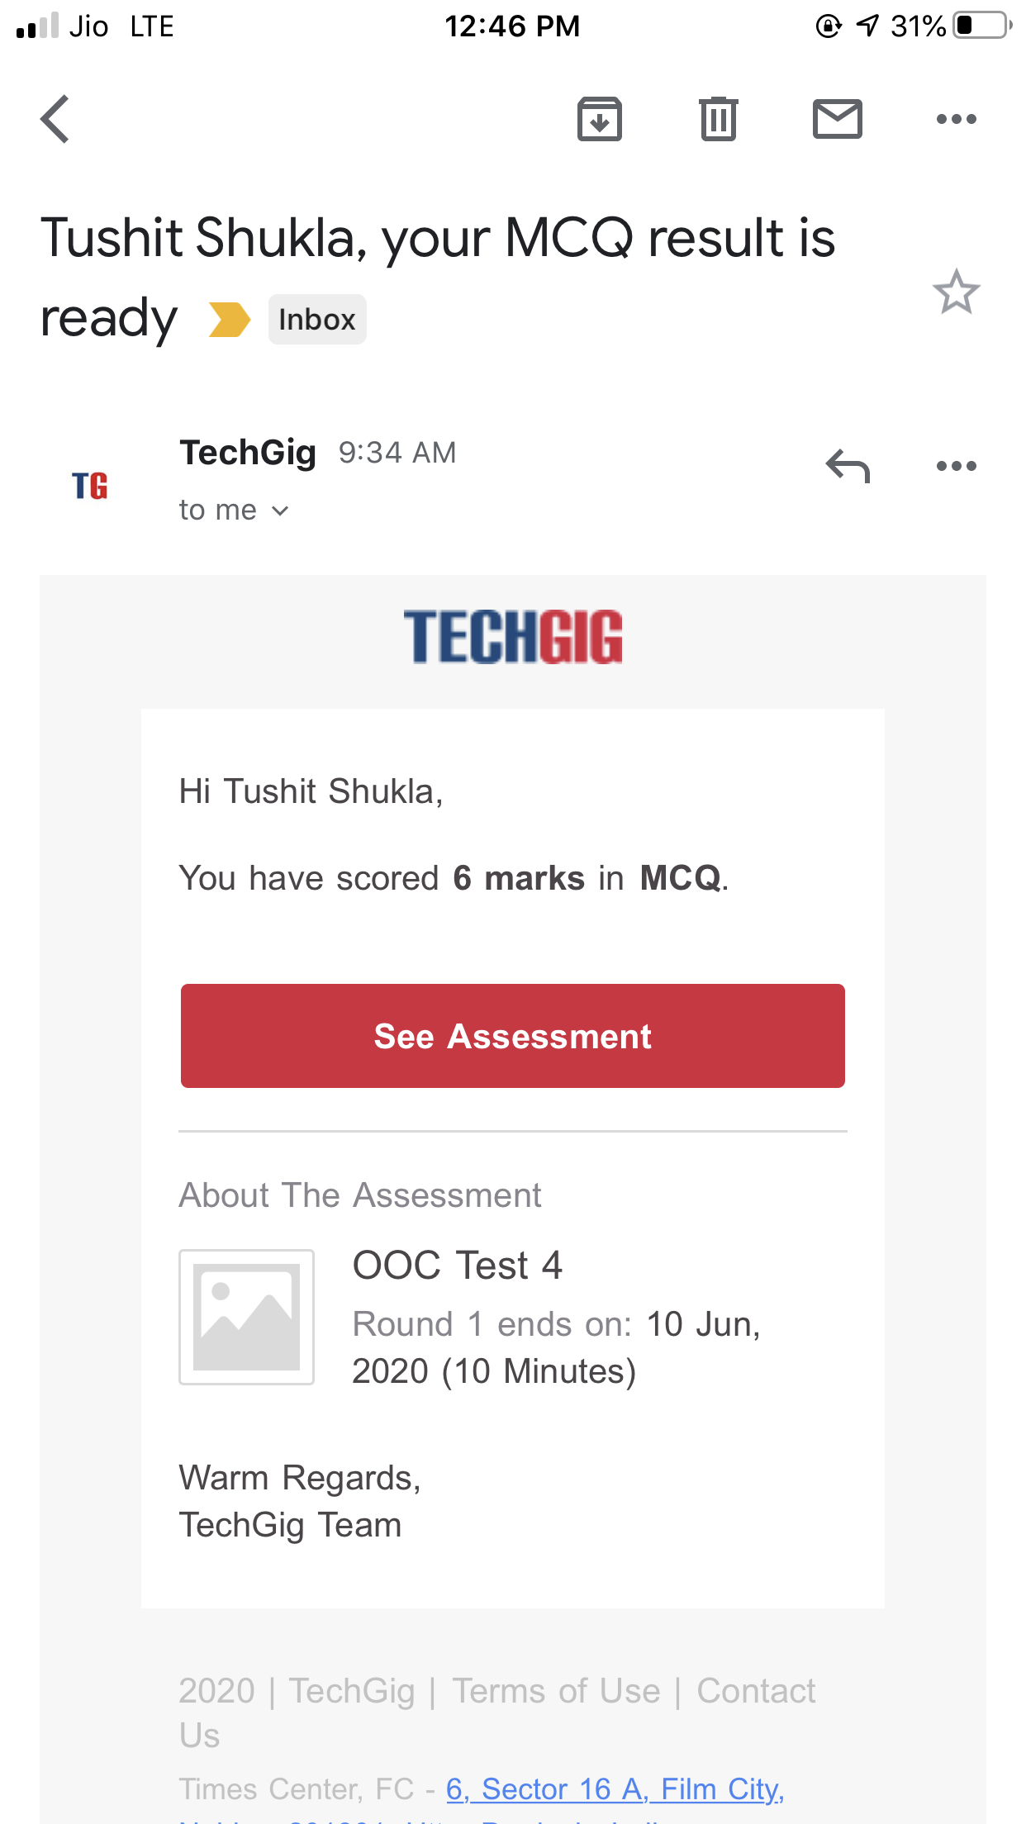

**Online Certification Details**:

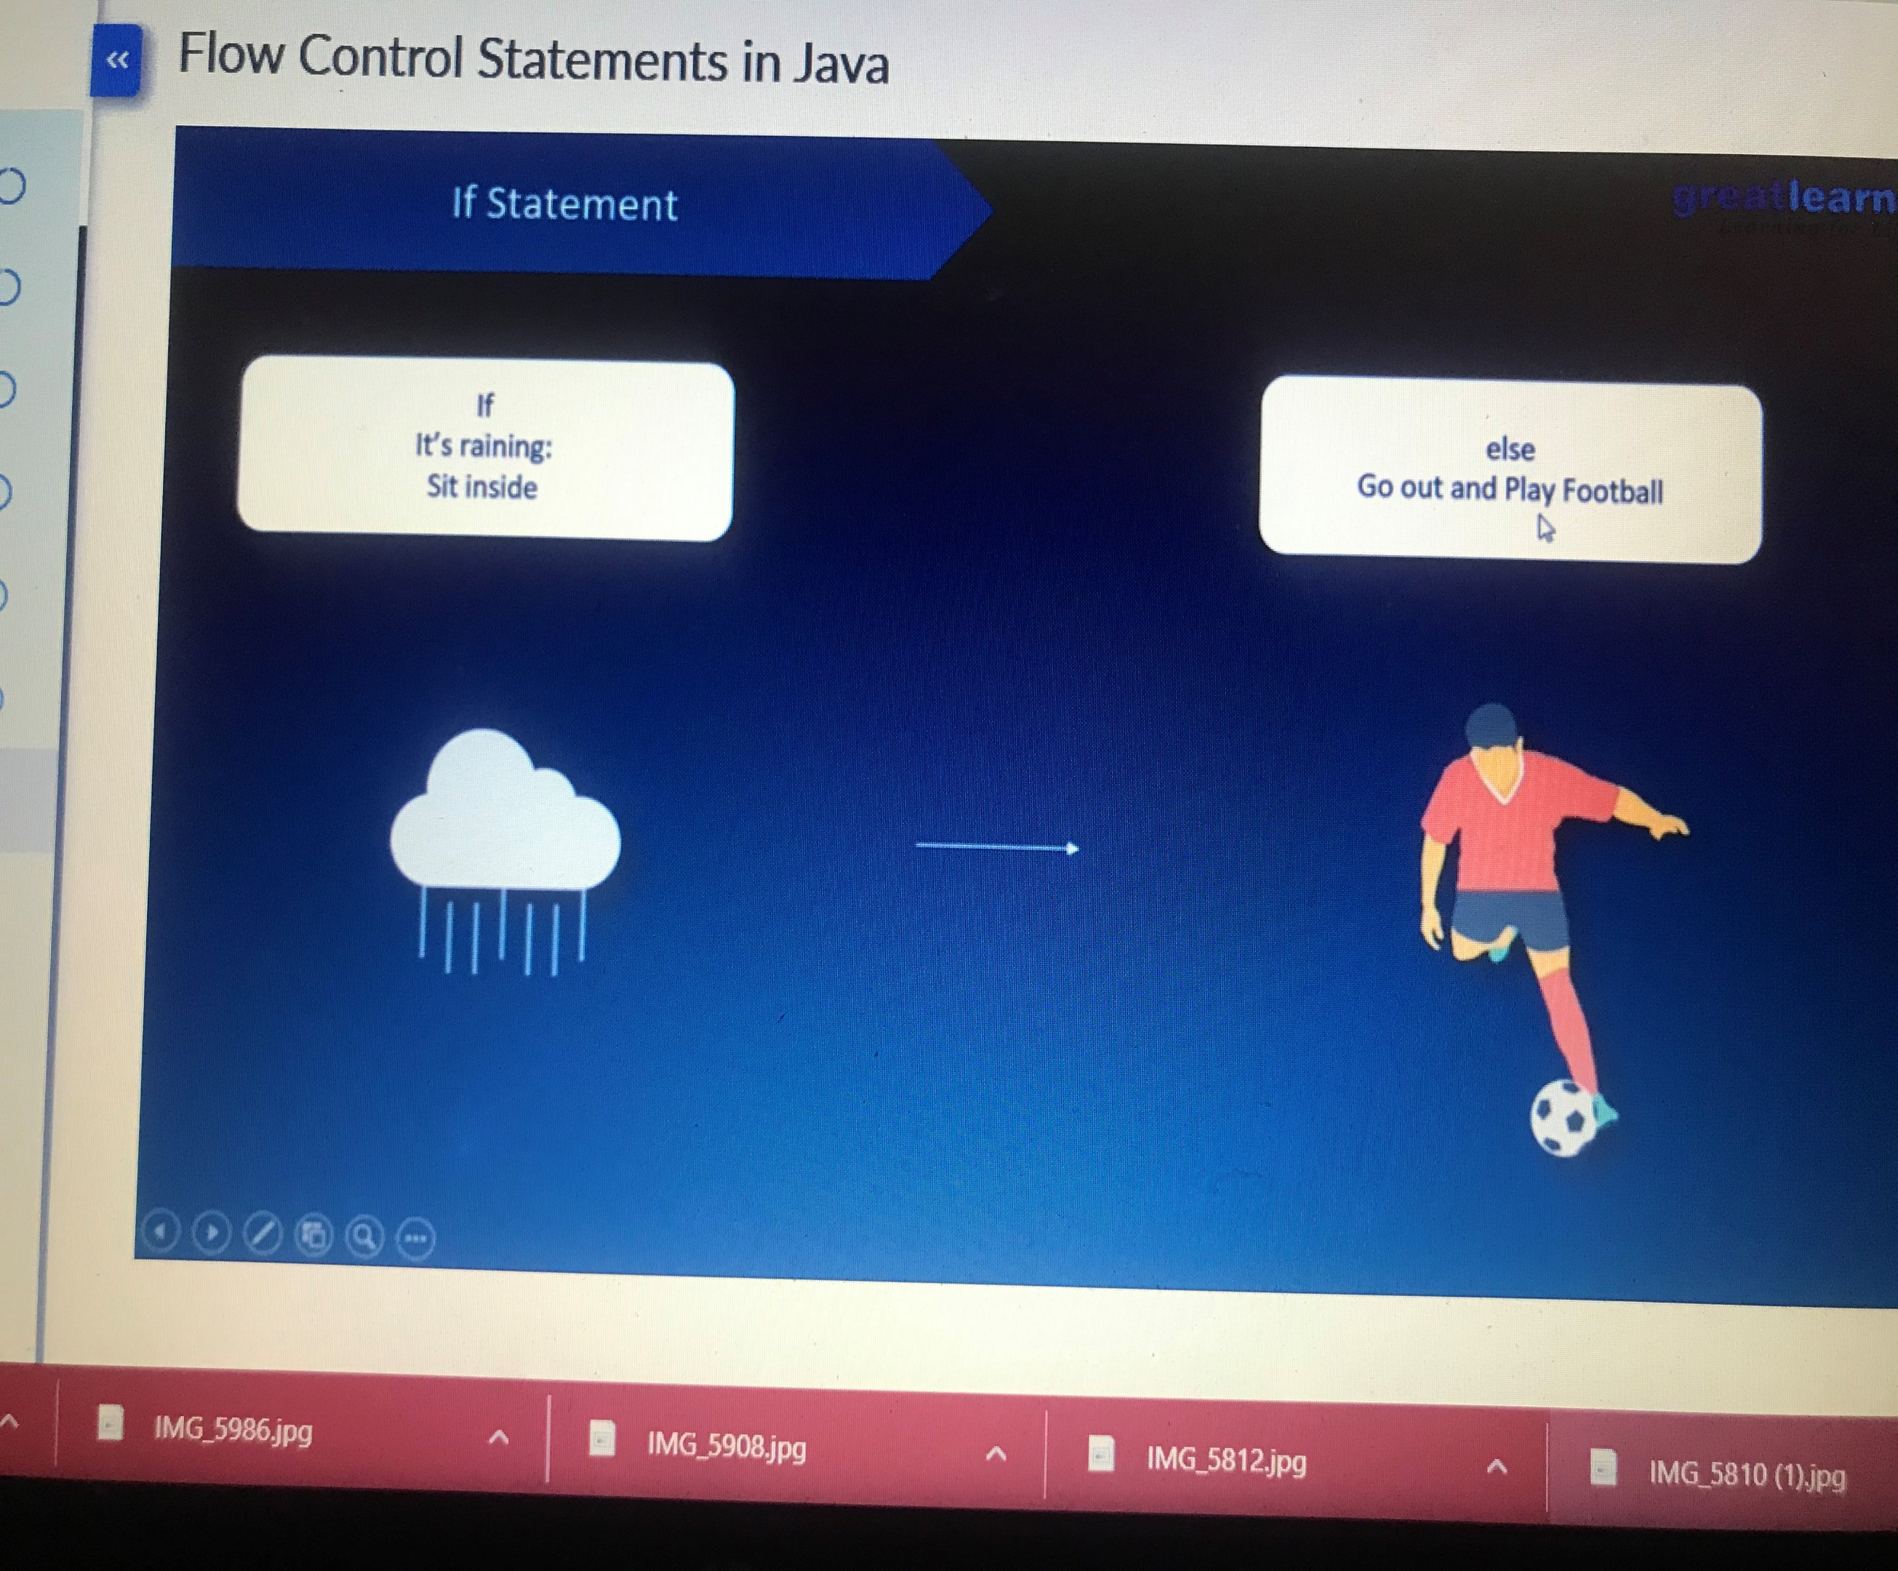

**Coding Challenge Detail :** I have written programs and uploaded it to my Github repository.

Link as follows: 1. <https://github.com/tushitshukla29/lockdown-program/blob/master/LongestRepeatingSequence>

1. <https://github.com/tushitshukla29/lockdown-program/blob/master/boundary>